FOODZONE Database Project Report

FINAL ANALYTICS REPORT:

1] INTRODUCTION
FOODZONE is a Food Delivery Database Management System developed using MySQL. This project manages information about customers, restaurants, menu items, orders, payments, deliveries, reviews, coupons, food categories, and delivery partners.
The project demonstrates basic and advanced SQL concepts such as queries, joins, subqueries, views, procedures, functions, triggers, events, transactions, and window functions. It also helps analyze customer activity, orders, revenue, and delivery performance.

2]Executive Summary
The FOODZONE database was analyzed to understand customer activity, order performance, revenue, and delivery performance.
Metric | Result
Total Customers | 50
Total Orders | 302
Total Revenue | ₹179,070.00
Average Order Value | ₹592.95
Delivered Orders | 180

Key Findings

1. Customer Analysis
The FOODZONE database contains 50 registered customers.

2. Order Analysis
A total of 302 orders were recorded in the system.

3. Revenue Analysis
The total revenue generated from orders is ₹179,070.00.

4. Average Order Value
The average value of an order is ₹592.95.

5. Delivery Analysis
Out of 302 total orders, 180 orders were successfully delivered.

3] ER DIAGRAM
The following EER Diagram represents the structure and relationships between the tables in the FOODZONE database.

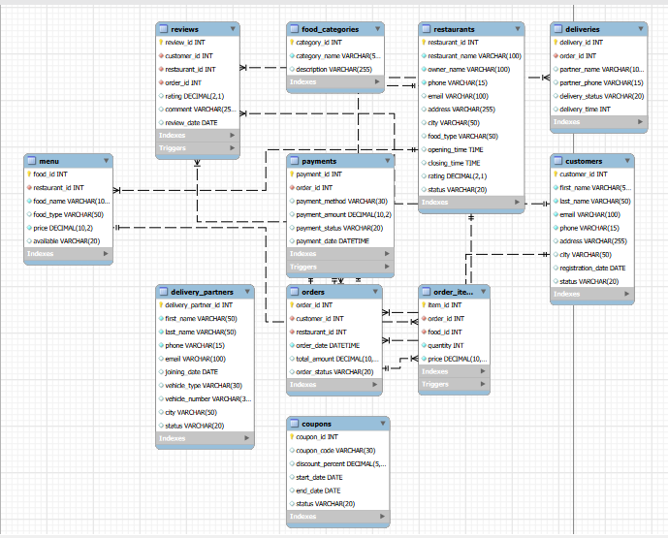

4] DATABASE SCHEMA
The FOODZONE database consists of 11 tables used to manage different parts of the food delivery system.
Table Name | Description
Customers | Stores customer information.
Restaurants | Stores restaurant information.
Menu | Stores food items and their prices.
Orders | Stores customer order details.
order_items | Stores items included in each order.
Payments | Stores payment details.
Deliveries | Stores delivery information.
Coupons | Stores discount coupon details.
Reviews | Stores customer reviews and ratings.
food_categories | Stores different food categories.
delivery_partners | Stores delivery partner information.

5. NORMALIZATION
Normalization is the process of organizing data in a database to reduce duplication and improve data consistency.

1NF (First Normal Form)

Each column contains a single value, and every record is unique.

2NF (Second Normal Form)
The database removes partial dependency and organizes related data into separate tables.

3NF (Third Normal Form)
The database removes unnecessary dependencies and reduces data redundancy by separating information into different related tables.
The FOODZONE database is organized into separate tables such as customers, restaurants, orders, menu, payments, and deliveries, making the database more structured and efficient.

6] SQL IMPLEMENTATION
The FOODZONE project uses different SQL queries to manage and analyze the database.
The following SQL concepts were implemented:
- SELECT – To retrieve data from tables.
- WHERE – To filter specific records.
- ORDER BY – To sort data.
- LIMIT – To display a limited number of records.
- Aggregate Functions – COUNT, SUM, AVG, MAX, and MIN.
- GROUP BY – To group data for analysis.
- HAVING – To filter grouped results.
- JOINs – To combine data from multiple tables.
- Subqueries – To perform queries inside other queries.

7] ADVANCED SQL FEATURES
The FOODZONE project also demonstrates advanced MySQL features to perform more complex database operations.
The following advanced SQL concepts were implemented:
- Views – Used to create reusable reports.
- Stored Procedures – Used to perform predefined database operations.
- User-Defined Functions – Used for calculations and business logic.
- Triggers – Automatically perform actions when data is inserted or updated.
- Events – Used to schedule automatic database tasks.
- Window Functions – Used for ranking and analyzing records.
- Transactions – Used to safely manage operations using COMMIT, ROLLBACK, and SAVEPOINT.

8] FINAL ANALYTICS REPORT
The FOODZONE database was analyzed using SQL queries to understand customer activity, order performance, revenue, and delivery performance.
The analysis showed that the database contains 50 customers and 302 orders. The total revenue generated was ₹179,070.00, with an average order value of ₹592.95. Out of all orders, 180 orders were successfully delivered.

9] BUSINESS ANALYSIS
The FOODZONE database was analyzed to understand the overall performance of the food delivery system.
The analysis shows information about customers, orders, revenue, restaurants, and deliveries.

Key Business Insights
- The system has 50 registered customers.
- A total of 302 orders were recorded.
- The total revenue generated was ₹179,070.00.
- The average order value was ₹592.95.
- 180 orders were successfully delivered.
This analysis helps the business understand its performance and make better decisions regarding sales, customers, restaurants, and delivery services

10. CONCLUSION
The FOODZONE – Food Delivery Database Management System was successfully developed using MySQL and MySQL Workbench.
This project helped in understanding database design, table relationships, SQL queries, and advanced SQL concepts. The system manages customers, restaurants, menu items, orders, payments, deliveries, and reviews.
The project also demonstrated advanced features such as Views, Stored Procedures, Functions, Triggers, Events, Window Functions, and Transactions.
.
The project also demonstrated advanced features such as Views, Stored Procedures, Functions, Triggers, Events, Window Functions, and Transactions.

